LIBRARY MANAGEMENT SYSTEM

IN JAVA PROGRAMMING

MINI-PROJECT REPORT

Submitted by

|  |  |
| --- | --- |
| **MUTHUKUMARAN.N** | **REG.NO: 16TD1247** |
| **LAKSHMI NARASIMHA RAO KARRI** | **REG.NO: 16TD1243** |
| **NAVEEN KUMAR.V.S**  **MOHAMED SUHAL.M** | **REG.NO: 16TB1249**  **REG.NO:16TH1244** |

Under the Guidance of MR.R.RAJ BHARATH

Assistant Professor

*In partial fulfillment of the requirement for the award of the Degree of*

BACHELOR OF TECHNOLOGY IN

COMPUTER SCIENCE AND ENGINEERING PONDICHERRY UNIVERSITY



DEPARTMENT OF COMPUTER SCIENCE AND ENGINEERING MANAKULA VINAYAGAR INSTITUTE OF TECHNOLOGY KALITHEERTHALKUPPAM, PUDUCHERRY - 605 107.

**JAN-2018**

# MANAKULA VINAYAGAR INSTITUTE OF TECHNOLOGY

## DEPARTMENT OF COMPUTER SCIENCE AND ENGINEERING

**BONAFIDE CERTIFICATE**

This is to certify that the Mini-Project Work titled **“LIBRARY MANAGEMENT SYSTEM IN JAVA PROGRAMMING”** is a bonafide work done by **N.MUTHUKUMARAN** [REGISTERNO:16TD1247], **LAKSHMI NARASIMHA RAO KARRI** [REGISTER NO: 16TD1243], **V.S.NAVEEN KUMAR**[REGISTER NO: 16TB1249], and **MOHAMED SUHAL**[REGISTER NO: 16TH1244]in partial fulfillment for the award of the degree of Bachelor of Technology in Computer Science And Engineering of the Pondicherry University during the academic year 2017-18.

Project guide, Head of Department,

MR.R. Raj bharath, Dr.S.Pariselvam,

Assistant Professor/CSE. Dept. of CSE.

**ABSTRACT**

The main objective of the project is to develop Library management system for collages. In present system all registration work is done manually. Users have to visit bank to Withdrawal or Deposit amount. In present bank system it is also report of the student. In this library management system we will automate all the library process. In our library management system administrator can check the book is submitted or renewal can be done. In this Software you can keep record for daily book issues. The main purpose of developing library management system is to design an application, which could store library data. This library management system also allow user to add new student details, delete details of student and user can also modify existing user details information. Using this system user can also search any individual student and book details in few seconds.

**INTODUCTION :**

“Library management System" keeps the day  by day tally record as a complete banking. It can keep the information of login , home module, The exciting part of this project is; it displays Transaction reports, Statistical Summary of Account type and Interest Information. "Bank Management System" has been designed to computerize the following functions that are performed by the system.

**CUSTOMER DETAILS FUNCTION:**

* User login
* Book issue
* Book return
* Book renewal
* Report

**EXISTING SYSTEM**

In the existing system the book issue and return details are done only manually but in proposed system we have to computerize all the library management system using the software called library management system.

**PROBLEMS WITH EXISTING SYSTEM**

• Lack of security of books.  
• consumption of man power.  
• More time consuming.  
• Consumes large volume for report and records  
• Needs manual calculations.  
• No direct role for the higher officials.  
• Damage of machines due to lack of attention.

To avoid all these limitations and make the working more accurately the system needs to be computerized.

**PROPOSED SYSTEM**

**AIM:**

To create project on Library Management system in programming java.

**Module Description:**

**LOGIN MODULE:**

In login module the librarian/Administrator can login to know about the details of students whether they have fine, whether the book is returned . Details of the student and book can be notice.

**HOME MODULE:**

In home module the buttons like book issue ,book return ,book renewal, report buttons can be provided.

**BOOK ISSUE MODULE,BOOK RETURN MODULE, BOOK RENEWAL MODULE:**

In book issue module the librarian/Administrator can get the details of the students like student name, student id, department, book name, no_of_book, issue date and return date.

**Future scope of the proposed system:**

We can consider much future scope to this application. The following are some of there.

* Online use of the library can be good feature for the Library Management system.
* Advanced report system can be added.
* Inventory system can be used to maintain the books of the library.

**Software requirement :**

* Java language
* MS SQL server 2005

**ADVANTAGES OF THE PROPOSED SYSTEM**

The system is very simple in design and to implement. The system requires very low system resources and the system will work in almost all configurations.

• Security of books.  
• Ensure date accuracy’s.  
• Proper control of the management.  
• Reduce the damages of the books.  
• Minimize manual data entry.  
• Minimum time needed for the various processing.  
• Greater efficiency.  
• Better service.  
• User friendliness and interactive.  
• Minimum time required.

**LOGIN MODULE:**

This project aims at creation of a LABRARY MANAGEMENT SYSTEM. This will be accessible to all customers who have a valid User Id and Password. This is an approach to provide an opportunity to the user to have some important record management of library to be done. In this project we are going to deal the existing facts in the library i.e.; the library which takes place between customer and library. We provide a real time environment for the existing system in the library

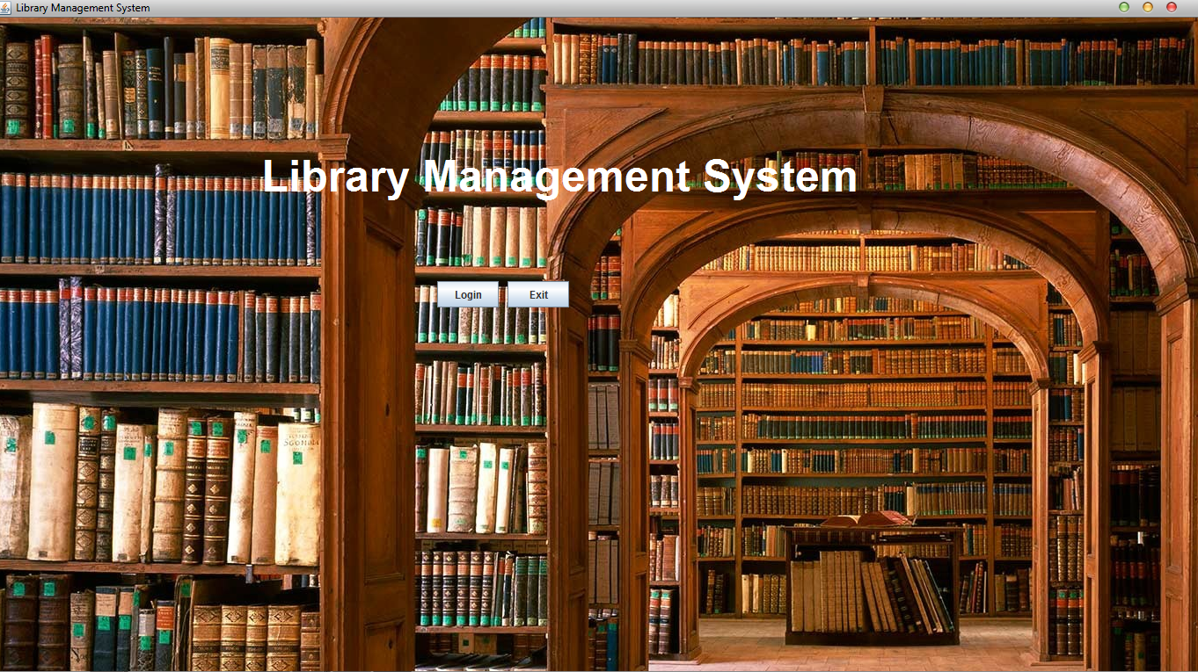

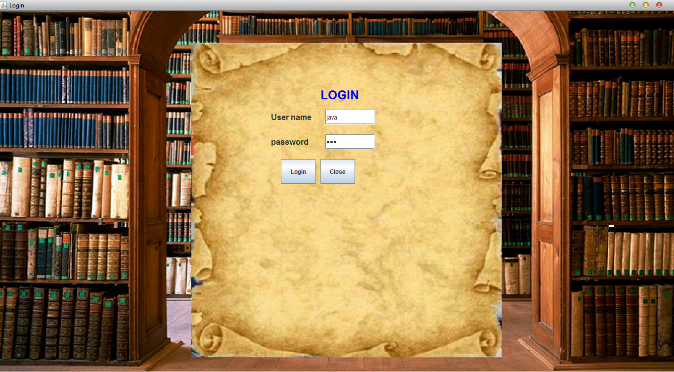

**HOME MODULE:**

This home module is to give a detailed report about the Book issue, Book return, Book renewal, Report.

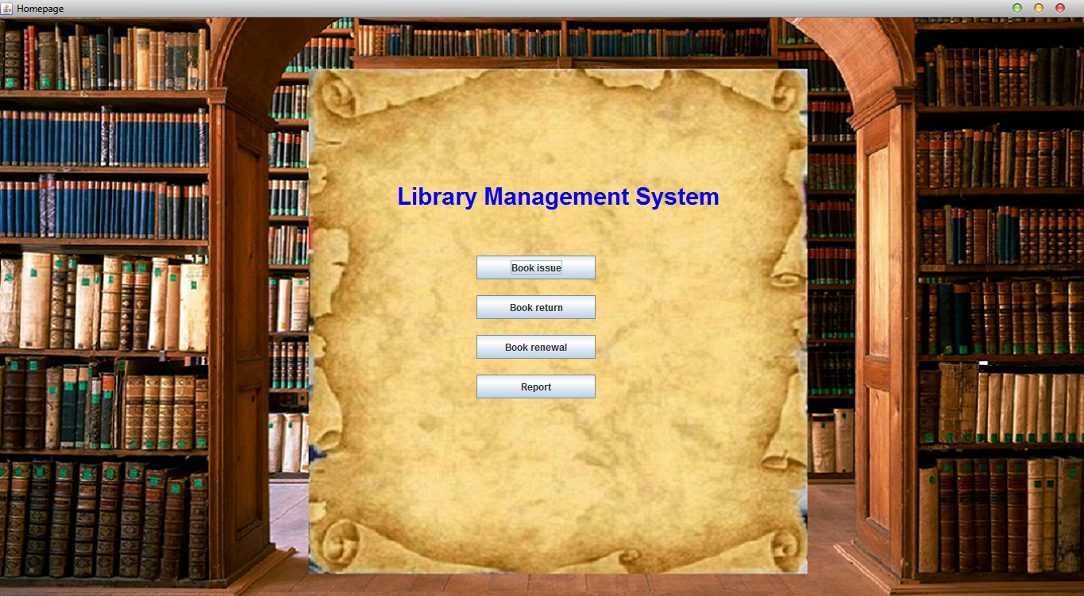

**BOOK ISSUE MODULE:**

The book issue module is which consists of some information about users and book that which the user needs and these information can be save , search , update , delete , reset , close, back .

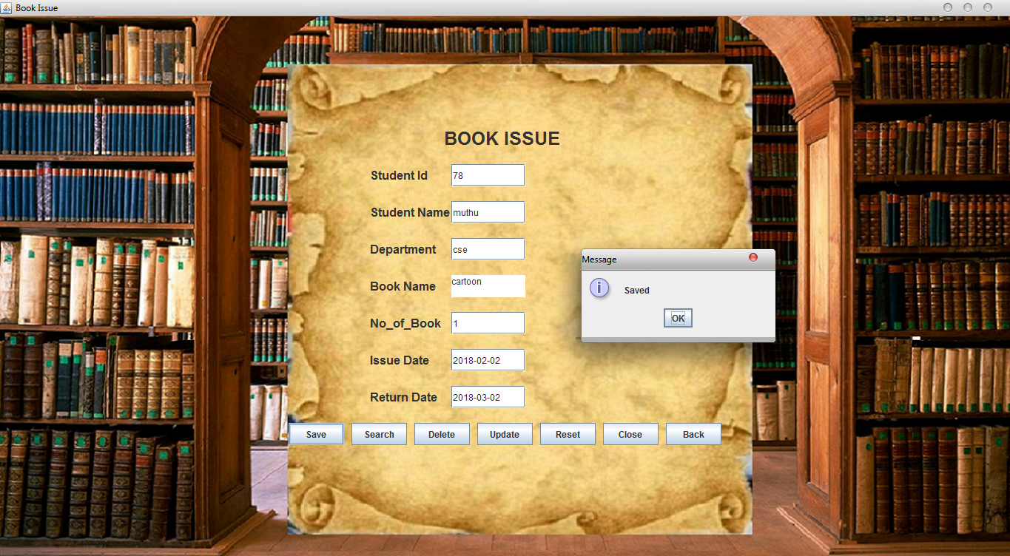

**BOOK RENEWAL MODULE:**

The book renewal module is which consists of some information about users and book that which the user needs and these information can be edit, renewal, exit, back.

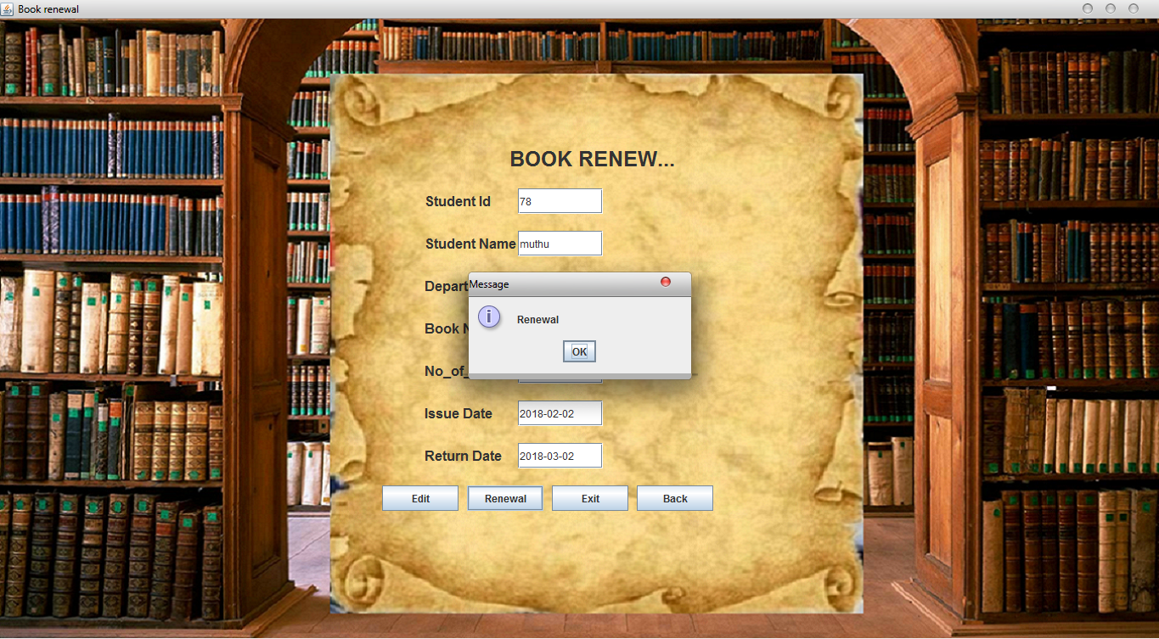

**BOOK RETURN MODULE:**

The book return module is which consists of some information about users and book that which the user needs and these information can be edit, return, exit, back.

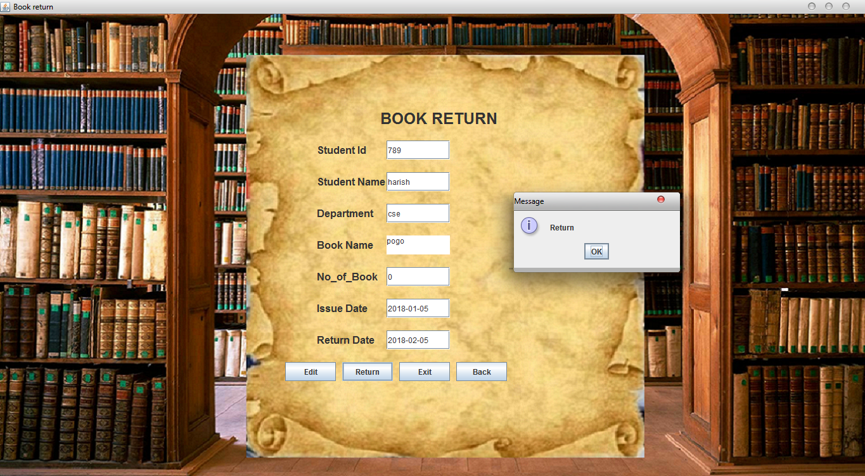

**REPORT MODULE:**

The report module is display the student name, student id, department, book name, no_of_book, issue date and return date.

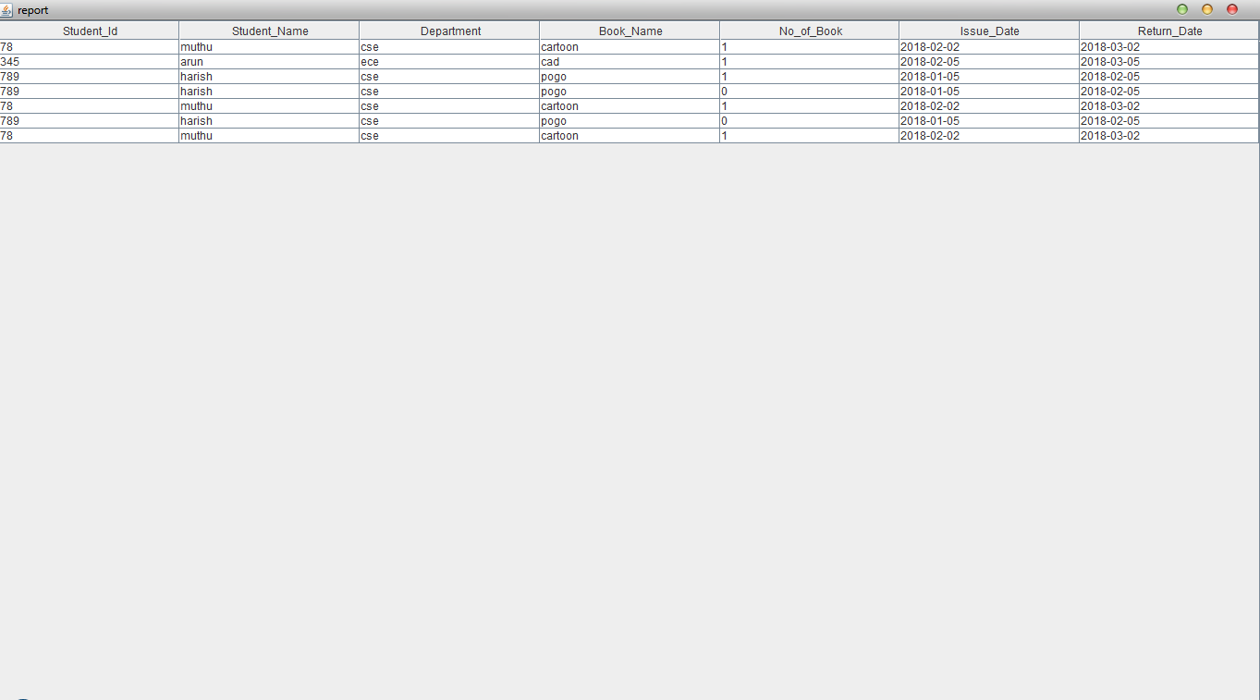

**SOURCE CODE:**

**Homepage:**

**import java.sql.*;**

**import javax.swing.*;**

**import java.awt.*;**

**import java.awt.event.*;**

**class homepage implements ActionListener**

**{**

**JFrame f;**

**JPanel p;**

**JLabel l;**

**JButton b,b1,b2,b3;**

**homepage()**

**{**

**f=new JFrame("Homepage");**

**p=new ImagePanel(new ImageIcon("1.png").getImage());**

**f.getContentPane().add(p);**

**f.setVisible(true);**

**f.setSize(1024,768);**

**p.setLayout(null);**

**//f.getContentPane().setBackground(Color.gray);**

**Font f1=new Font("Arial",Font.BOLD,30);**

**l=new JLabel("Library Management System");**

**l.setFont(f1);**

**l.setForeground(Color.blue);**

**b=new JButton("Book issue");**

**b.addActionListener(this);**

**b1=new JButton("Book return");**

**b1.addActionListener(this);**

**b2=new JButton("Book renewal");**

**b2.addActionListener(this);**

**b3=new JButton("Report");**

**b3.addActionListener(this);**

**l.setBounds(500,200,500,50);**

**b.setBounds(600,300,150,30);**

**b1.setBounds(600,350,150,30);**

**b2.setBounds(600,400,150,30);**

**b3.setBounds(600,450,150,30);**

**p.add(l);**

**p.add(b);**

**p.add(b1);**

**p.add(b2);**

**p.add(b3);**

**}**

**public void actionPerformed(ActionEvent ae)**

**{**

**try**

**{**

**Class.forName("com.mysql.jdbc.Driver");**

**Connection c=DriverManager.getConnection("jdbc:mysql://localhost/library","root","root");**

**Statement s=c.createStatement();**

**ResultSet rs=s.executeQuery("select * from login");**

**if(ae.getSource()==b)**

**{**

**new bookissue();**

**f.dispose();**

**f.setVisible(false);**

**}**

**if(ae.getSource()==b1)**

**{**

**new bookreturn();**

**f.dispose();**

**f.setVisible(false);**

**}**

**if(ae.getSource()==b2)**

**{**

**new bookrenewal();**

**f.dispose();**

**f.setVisible(false);**

**}**

**if(ae.getSource()==b3)**

**{**

**new report();**

**f.dispose();**

**f.setVisible(false);**

**}**

**}**

**catch(Exception e)**

**{**

**JOptionPane.showMessageDialog(f,e);**

**//System.out.println(e);**

**}**

**}**

**public static void main(String ar[])**

**{**

**new homepage();**

**}**

**}**

**Book issue:**

**import java.sql.*;**

**import javax.swing.*;**

**import java.awt.*;**

**import java.awt.event.*;**

**class bookissue implements ActionListener**

**{**

**JFrame f;**

**JPanel p;**

**JLabel l,l1,l2,l3,l4,l5,l6,l7;**

**JTextField t1,t2,t3,t5,t6,t7;**

**JTextArea t4;**

**JButton b,b1,b2,b3,b4,b5,b6;**

**int count;**

**bookissue()**

**{**

**f=new JFrame("Book Issue");**

**p=new ImagePanel(new ImageIcon("1.png").getImage());**

**f.getContentPane().add(p);**

**f.setVisible(true);**

**f.setSize(1000,1000);**

**p.setLayout(null);**

**//f.getContentPane().setBackground(Color.gray);**

**Font f1=new Font("Arial",Font.BOLD,16);**

**Font f2=new Font("Arial",Font.BOLD,25);**

**l=new JLabel("BOOK ISSUE");**

**l.setFont(f2);**

**l1=new JLabel("Student Id");**

**l1.setFont(f1);**

**t1=new JTextField(30);**

**l2=new JLabel("Student Name");**

**l2.setFont(f1);**

**t2=new JTextField(30);**

**l3=new JLabel("Department");**

**l3.setFont(f1);**

**t3=new JTextField(30);**

**l4=new JLabel("Book Name");**

**l4.setFont(f1);**

**t4=new JTextArea(5,5);**

**l5=new JLabel("No_of_Book");**

**l5.setFont(f1);**

**t5=new JTextField(30);**

**l6=new JLabel("Issue Date");**

**l6.setFont(f1);**

**t6=new JTextField(30);**

**l7=new JLabel("Return Date");**

**l7.setFont(f1);**

**t7=new JTextField(30);**

**b=new JButton("Save");**

**b.addActionListener(this);**

**b1=new JButton("Search");**

**b1.addActionListener(this);**

**b2=new JButton("Delete");**

**b2.addActionListener(this);**

**b3=new JButton("Update");**

**b3.addActionListener(this);**

**b4=new JButton("Reset");**

**b4.addActionListener(this);**

**b5=new JButton("Close");**

**b5.addActionListener(this);**

**b6=new JButton("Back");**

**b6.addActionListener(this);**

**l.setBounds(600,150,200,30);**

**l1.setBounds(500,200,100,30);**

**t1.setBounds(610,200,100,30);**

**l2.setBounds(500,250,150,30);**

**t2.setBounds(610,250,100,30);**

**l3.setBounds(500,300,100,30);**

**t3.setBounds(610,300,100,30);**

**l4.setBounds(500,350,100,30);**

**t4.setBounds(610,350,100,30);**

**l5.setBounds(500,400,100,30);**

**t5.setBounds(610,400,100,30);**

**l6.setBounds(500,450,100,30);**

**t6.setBounds(610,450,100,30);**

**l7.setBounds(500,500,100,30);**

**t7.setBounds(610,500,100,30);**

**b.setBounds(390,550,75,30);**

**b1.setBounds(475,550,75,30);**

**b2.setBounds(560,550,75,30);**

**b3.setBounds(645,550,75,30);**

**b4.setBounds(730,550,75,30);**

**b5.setBounds(815,550,75,30);**

**b6.setBounds(900,550,75,30);**

**p.add(l);**

**p.add(l1);**

**p.add(t1);**

**p.add(l2);**

**p.add(t2);**

**p.add(l3);**

**p.add(t3);**

**p.add(l4);**

**p.add(t4);**

**p.add(l5);**

**p.add(t5);**

**p.add(l6);**

**p.add(t6);**

**p.add(l7);**

**p.add(t7);**

**p.add(b);**

**p.add(b1);**

**p.add(b2);**

**p.add(b3);**

**p.add(b4);**

**p.add(b5);**

**p.add(b6);**

**}**

**public void actionPerformed(ActionEvent a)**

**{**

**try**

**{**

**Class.forName("com.mysql.jdbc.Driver");**

**Connection c=DriverManager.getConnection("jdbc:mysql://localhost/library","root","root");**

**Statement s=c.createStatement();**

**ResultSet rs;**

**if(a.getSource()==b)**

**{**

**int r=s.executeUpdate("insert into info values('"+t1.getText()+"','"+t2.getText()+"','"+t3.getText()+"','"+t4.getText()+"','"+t5.getText()+"','"+t6.getText()+"','"+t7.getText()+"')");**

**if(r!=0)**

**{**

**JOptionPane.showMessageDialog(f,new String("Saved"));**

**}**

**t1.setText("");**

**t2.setText("");**

**t3.setText("");**

**t4.setText("");**

**t5.setText("");**

**t6.setText("");**

**t7.setText("");**

**}**

**if(a.getSource()==b1)**

**{**

**rs=s.executeQuery("Select * from info where Student_Id='"+t1.getText()+"'");**

**while(rs.next())**

**{**

**count++;**

**t2.setText(rs.getString(2));**

**t3.setText(rs.getString(3));**

**t4.setText(rs.getString(4));**

**t5.setText(rs.getString(5));**

**t6.setText(rs.getString(6));**

**t7.setText(rs.getString(7));**

**}**

**if(count==0)**

**{**

**JOptionPane.showMessageDialog(f,"not found");**

**t1.setText("");**

**}**

**}**

**if(a.getSource()==b2)**

**{**

**int r=s.executeUpdate("delete from info where Student_Id='"+t1.getText()+"'");**

**if(r!=0)**

**{**

**JOptionPane.showMessageDialog(f,"Deleted");**

**}**

**t1.setText("");**

**t2.setText("");**

**t3.setText("");**

**t4.setText("");**

**t5.setText("");**

**t6.setText("");**

**t7.setText("");**

**}**

**if(a.getSource()==b3)**

**{**

**int r=s.executeUpdate("Update info set Student_Id='"+t1.getText()+"',Student_Name='"+t2.getText()+"',Department='"+t3.getText()+"',Book_Name='"+t4.getText()+"',No_of_Book='"+t5.getText()+"',Issue_Date='"+t6.getText()+"',Return_Date='"+t7.getText()+"'where Student_Id='"+t1.getText()+"'");**

**if(r!=0)**

**{**

**JOptionPane.showMessageDialog(f,new String("Updated"));**

**}**

**t1.setText("");**

**t2.setText("");**

**t3.setText("");**

**t4.setText("");**

**t5.setText("");**

**t6.setText("");**

**t7.setText("");**

**}**

**if(a.getSource()==b4)**

**{**

**t1.setText("");**

**t2.setText("");**

**t3.setText("");**

**t4.setText("");**

**t5.setText("");**

**t6.setText("");**

**t7.setText("");**

**}**

**if(a.getSource()==b5)**

**{**

**System.exit(0);**

**}**

**if(a.getSource()==b6)**

**{**

**new homepage();**

**f.dispose();**

**f.setVisible(false);**

**}**

**}**

**catch(Exception e)**

**{**

**JOptionPane.showMessageDialog(f,e);**

**//System.out.println(e);**

**}**

**}**

**public static void main(String ar[])**

**{**

**new bookissue();**

**}**

**}**